**CSIS 2260 - Lab #3**

20

***Windows 10* *Maintenance and System Restoration***

Due date: 20:59 Jan 29, 2021 (Pacific Time)

**Name: Stephen Joy Student No.: 300329148 Section: 012**

**Insert the required screenshots in the Word file. Do not submit the screenshots separately.**

**Use a different font color for your answers.**

**Objectives:**

To learn about Windows 10 system restoration, file recovery, and user account management.

**Open Oracle VM VirtualBox Manager and start the Windows 10 virtual machine created before. Work on the following parts on the virtual machine.**

1. **Eject the Installation ISO File from CD Drive [____/1]**
2. Open ***This PC***, right-click CD-Drive and select ***Eject***. Take a screenshot of the ***This PC*** window, which shows that the ISO file has been ejected (now the CD drive should be empty). Insert the screenshot in the space below.

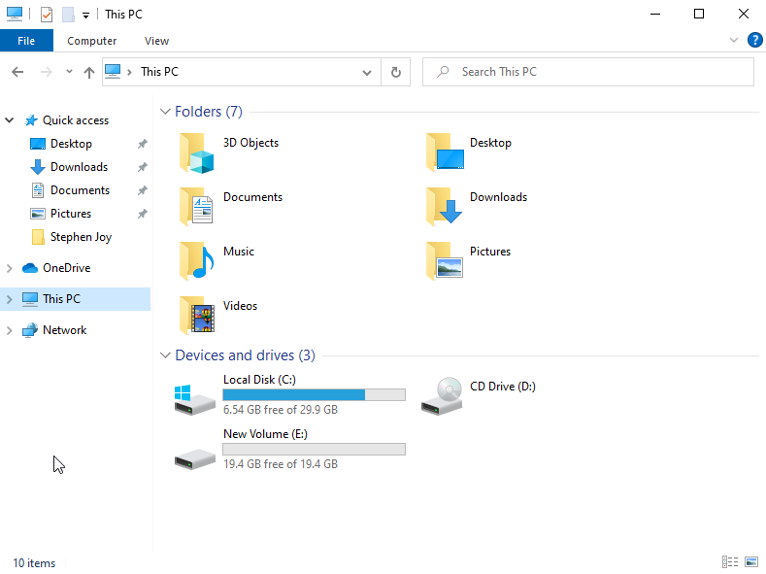

Note: After the ISO file is ejected, you will no longer see the message “*Press any key to boot from CD or DVD*” when you start the virtual machine each time.

1. **System Restoration [____/4]**

If your system experiences problem after an update or new software installation, you can restore your system back to a state before you made the changes to the system. Hence, it is advisable to create a restore point before carrying out any update or changes so that you can fall back to the previous state if the system does not perform well after the changes.

1. From ***Start*** > ***Windows*** ***System***, open the ***Control******Panel***. Change the ***Category*** at top right to ***Small******icons*** and select ***Recovery***.
2. Click the ***Configure System Restore***
3. In the pop-up window, under the ***System Protection*** tab, select the C: drive and click the ***Configure*** button. In the pop-up window, select ***Turn on system protection*** and click ***OK*** to enable system protection.
4. In the ***System Protection*** tab, select the C: drive and click the ***Create*** button to create a restore point now.
5. Type ***Lab 3*** as the description for the restore point. Click the ***Create*** button and wait for the restore point to be created.
6. Click *OK* to close the *System Properties* window.
7. Click ***Open System Restore*** in ***Recovery***
8. Click ***Next*** on the pop-up window.
9. How many restore points are there on your system? **1**
10. Take a screenshot that shows the available restore points and insert the screenshot in the space below.

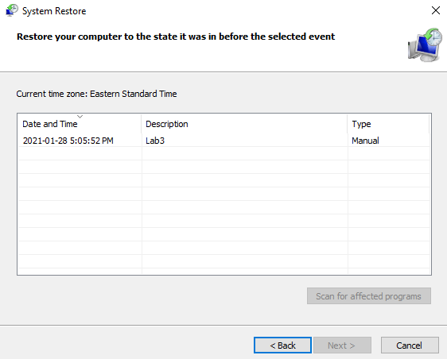

1. ***Optional*** - As the system restore will take quite a while, you do not have to do this step unless you want to try it out.

* Select the restore point that you have just created and restore the system to that point. The system will start to restore and will restart.
* Note that you can ***undo*** a restore if needed by selecting ***Open******System******Restore***again.

1. **Windows Recovery Environment (RE) [____/4]**

Normally, Windows will boot to ***Advanced******Startup******Options*** when the system encounters

* Two consecutive failed attempts to start Windows.
* Two consecutive unexpected shutdowns that occur within two minutes of boot completion.
* A Secure Boot error (except for issues related to Bootmgr.efi).
* A BitLocker error on touch-only devices.

However, you can also boot the system to Advanced Startup by using ***Shift-Restart*** as follows:Click on *Start* and click the power icon. Press and hold ***Shift*** key and click on ***Restart*** to restart your system. Wait for the system to restart.

* 1. Select ***Troubleshoot*** > ***Advanced******options*** from the display.
  2. What are the recovery options available?
* **Startup Repair**
* **Startup Settings**
* **Command Prompt**
* **Uninstall Updates**
* **System Restore**
* **System Image Recovery**
  1. Select ***Startup******Settings***and click***Restart***.
  2. After the system has restarted, list four of the options provided under ***Startup*** ***Settings***. Press ***Enter*** to return to your OS.
* **Enable debugging**
* **Enable boot logging**
* **Enable low-resolution video**
* **Enable Safe Mode**

1. **File Backup and Restore [____/6]**
2. Open ***This PC*** and create a folder with your first name as the folder name under C:\.
3. Open the ***Notepad*** application (Click ***Start*** and enter *notepad*) and type a few characters. Save the file as *text.txt* in the folder created in step 1. Similarly, open the ***Paint*** applicationand draw a simple picture. Save the file as *picture.png* in the folder created under C:\ in the last step.
4. Take a screenshot of the created folder that shows two the files have been created and insert the screenshot in the space below.

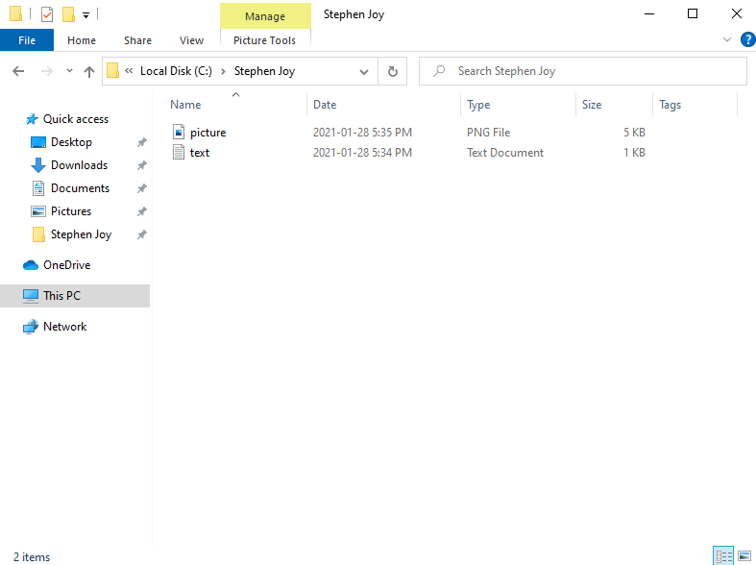

1. From ***Control******Panel***, select ***Backup and Restore****.*
2. Click ***Set******up******backup*** on the right.
3. Select the new volume that you created in lab 2 for backup and click *Next*.
4. Click ***Let******me******choose*** and select **ONLY** the folder that you have created on C:\ for backup. UNCHECK all the options under Data Files and make sure that the *Include a system image of drives* option at the bottom is also UNCHECKED.

(Note that normally you will create a backup for the system image, but as it takes a long while for the backup process, so we will not do this in the lab.)

1. Run the backup and take a screenshot of the ***Backup and Restore*** window when the backup finishes. Insert the screenshot in the space below.

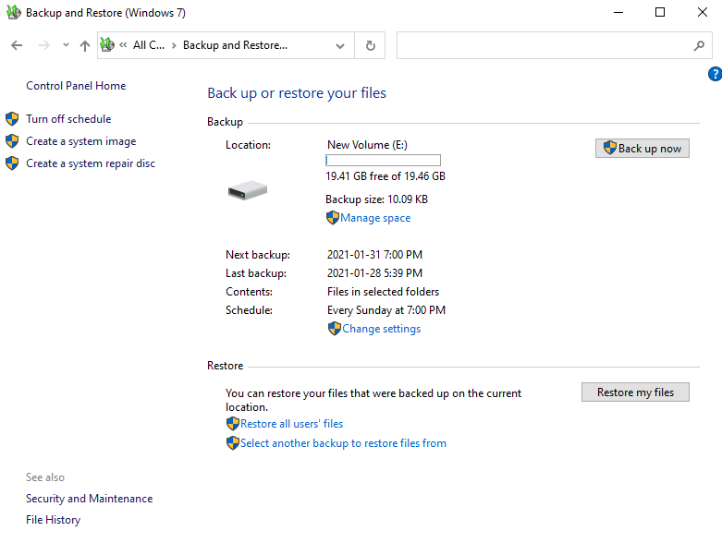

1. Delete the files in your folder, empty recycle bin, and use *Restore my files* to recover the files.
2. **User Account Management [____/5]**
3. From ***Start*** *>* ***Settings****,* click***Accounts***and select***Family & other users***.
4. Select ***Add someone else to this PC***
5. Add a user who does not have an email address or phone number (click *I don’t have this person’s sign-in information*) and add the user without a Microsoft account.
6. Create a new user account ***CSIS*** with **no** **password**.
7. Click ***Start*** and on the left side of the Start menu, select the account name icon (or picture), switch user to ***CSIS****,*and sign in. Select ***No*** to various settings when asked.
8. Look at the directory C:\Users. Can you access the directories of your original account WITHOUT the administrator password (click ***Continue*** in the pop-up window showing the message “*You don’t currently have permission to access this folder*”)? **No**
9. Sign out the ***CSIS*** account and sign in your original account. Can you access the directories of the ***CSIS*** account? **No**
10. From***Settings*** *>* ***Accounts*** *>* ***Family & other users***, select the account ***CSIS***, and click ***Change account type***.
11. What is the Account type of ***CSIS***?

**- Standard User**

1. What is the other option for Account type? Press ***Cancel*** to return to previous window.

**- Administrator**

1. Remove the account ***CSIS*** and close the ***Settings*** window.
2. From***Control******panel*** *>* ***User******Accounts***, select ***Change******your******account*** ***type***. Describe the differences between ***Standard***and ***Administrator***. Click ***Cancel*** to exit without changing the account type.

- Standard accounts can use most software and change system settings that don’t affect other users or the security of this PC whereas Administrators have complete control over the PC. They can change any settings and access all of the files and programs stored on the PC.

1. **Shutdown the Virtual Machine**
2. Shut down the system.
3. Close Oracle VM VirtualBox Manager.

**Submission**

1. Save your lab file as YourFirstname_yourID_Lab3.docx.
2. Submit the Word file through Blackboard before the due (do not send labs by email please. Any lab submitted by email will be ignored). Late submissions will not be marked, and the student will lose the mark of that lab.
3. You may submit your work multiple times, but only the LAST submission before the due will be graded.